IBM ASSIGNMENT-1

Smart Home(using 2 sensors, led and buzzer)

// C++ code

//

int trigPin =16;

int echoPin =5;

int vcc=13;

int gnd=10;

int buzzer=7;

int LED=8;

float temp;

float vout;

float vout1;

int gassensor;

int piezo =-6;

//define variables

long duration;

int distance;

void setup()

pinMode(trigPin, OUTPUT);

pinMode(echoPin,INPUT);

pinMode(vcc,OUTPUT);

pinMode(gnd,OUTPUT);

pinMode(buzzer,OUTPUT);

digitalWrite(vcc,HIGH);

digitalWrite(gnd,LOW);

pinMode(A0,INPUT);

pinMode(A1,INPUT);

pinMode(LED,OUTPUT);

pinMode(piezo,OUTPUT);

Serial.begin(9600);

}

void loop(){

vout=analogRead(A1);

vout1=(vout/1023)\*5000;

temp=(vout1-500)/10;

gassensor=analogRead(A0);

if (temp>=80){

digitalWrite(LED,HIGH);

}

else{

digitalWrite(LED,LOW);

}

if (gassensor>=100)

{

digitalWrite(piezo,HIGH);

}

else

{

digitalWrite(piezo,LOW);

}

Serial.print("in degreeC= ");

Serial.print(" ");

Serial.print(temp);

Serial.print("\t");

Serial.print("Gassensor= ");

Serial.print(" ");

Serial.print(" ");

Serial.print(gassensor);

Serial.print();

//

//

//

//

digitalWrite(trigPin,HIGH);

delayMicroseconds(10);

digitalWrite(trigPin,LOW);

//

duration=pulseIn(echoPin,HIGH);

//

distance=duration\*0.034/2;

//

//

Serial.print("Distance: ");

Serial.print(distance);

delay(1000);

if (distance<50)

{

digitalWrite(buzzer,HIGH);

}

else

{

digitalWrite(buzzer,LOW);

}

}

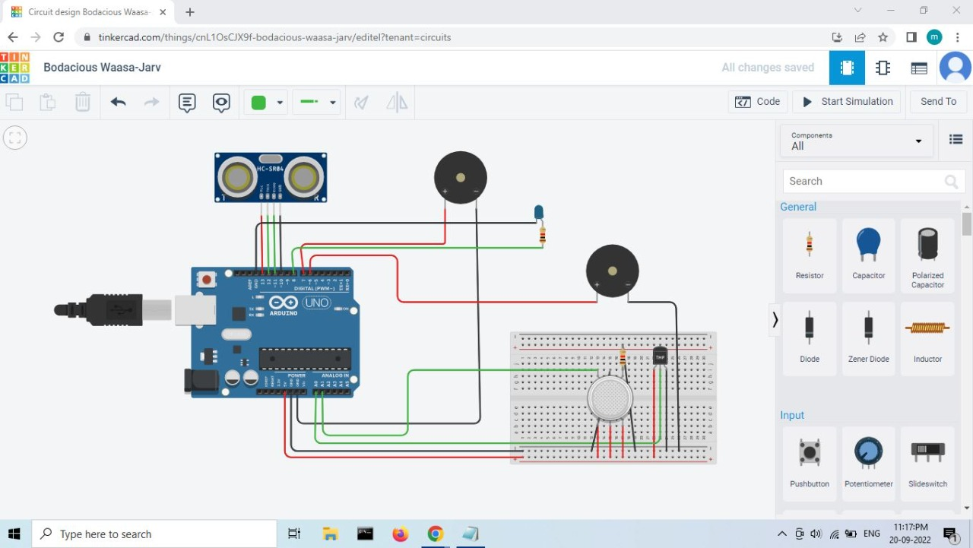

SUBMITTED BY:

Team leader: Mothika .R -962319104058

Team member: Padmesh .G.N -962319104066

Team member: Sree varsha.S.V -962319104088

Team member: Mani.K.V- 962319104056